Agent Based Modelling for simulating the Interregional Patient Mobility in Italy

Fabrizio PECORARO, First AUTHORa,[1] and Second AUTHOR b

a IRPPS-CNR

b Affiliation

ORCiD ID: Author Name <https://orcid.org/....-....-....-....>

**Abstract.** Abstract goes here.

**Keywords.** Keyword, keyword

# Introduction

Patient mobility is a complex phenomenon considered as a proxy for the quality and availability of hospital services [1]. This is particularly evident in Italy, a decentralized tax-funded health system affected by significant socio-economic disparities at regional level [2,3]. Moreover, compared with other European countries, in Italy, patients tend more frequently to travel long distances to access to care [4] especially for elective treatments [5]. Patient mobility across Italian regions has been widely studied to capture factors that may influence the patients’ choice [1], including social, demographic and economic status [6], quality and complexity of regional services [7] as well as structural components related to personnel, technologies and equipment available [8]. Moreover, our previous studies [R] have underlined the impact of hospital accessibility on interregional patient mobility in Italy taking into account two fundamental aspects of universal care: the accessibility in terms of travel distance and the availability of extra-regional facilities in particular for patients living at the regional borders [9].

… introduce here the ABM to simulate patient’s mobility across regions… This analysis may provide an input for policy makers to capture to what extent the capacity and distribution of hospitals and beds may affect patient’s flows at regional level.

Within this context, the aim of this study is to …

First paragraph.

Second paragraph.

# Materials and methods

## Data collection and factor identification

Data on hospitals and mobility was gathered from the Ministry of Health (MoH) website [X] and from the National Outcomes Programme website [X], while demographic data was collected from the Italian National Institute of Statistics (ISTAT) website [X]. All data refers to the year 2019. In this study we investigated the hip replacement surgery services. This is mainly an elective treatment where patients is generally prepared to travel beyond their nearest provider in particular in countries that allow patients to freely choose their place of care [12].

To identify which variables mostly impact on patient mobility, we applied the best subsets regression function of R [] that tests all possible combination of the predictor variables and then selects the best model according to the highest adjusted R squared value. The resultant regression model is reported in equation 1 with all variables statistically significant (p < 0.05) with multiple R2 = 0.6634 and adjusted R2 = 0.6426:

where *wait* represents the number of days a patient has to wait for accessing the service (at regional level), *sat* describes the level of patient’s satisfaction due to the last hospital admission (at regional level), while ${int }_{intra}$, ${ret }_{intra}$ and ${bed }_{intra}$ describe, respectively, the number of interventions, the percentage of patients returned to hospital in the following 2 years after the intervention and the number of beds available for orthopedics. These hospital related indicators have been computed based on a gravity model which relates the increasing probability to access to a hospital with the its capacity and quality and the patient-to-hospital distance. For further details please see [R]. Note that indicators specifically related to the patient (i.e. income, education) have been discarded from the initial model as they were not statistically significant.

## Simulation process

The simulation model was defined using Netlogo version X, on the basis of the following steps:

1. Whole sample population identification: based on age and sex risk factors. The total number of patients extracted are 100.000.
2. Patient extraction: for each test 52.000 patients were extracted and queued to access the service. For each patient a liability index was computed that describes the probability that the patient travels outside the region to be treated.
3. Depending on the patient choice (stay or go outside in his/her region of residence) he/she access the service on a specific hospital depending on its availability, accessibly and quality of services.

The simulation model were executed in ten specific sessions (each one including 52.000 patients): five sessions with the same patients accessing the service with the same order, while in the additional five sessions patients are randomly extracted from the whole sample population. The results of these two distinct sessions were analyzed to capture the accuracy (i.e. reproducibility) and the precision (i.e. repeatability) of the model. In particular, the accuracy was assessed using the regression coefficient between the simulated data and the mobility gathered from the multiple linear regression model. To assess the precision of the model we adopted the intraclass correlation coefficient (ICC(2,1)) where the passive mobility of each province is assessed in five different simulated sessions each one represented by a single measurement.

# Results

XXX Brief description of the environment to highlight the existence of the model and that the algorithm has actually been implemented. XXX

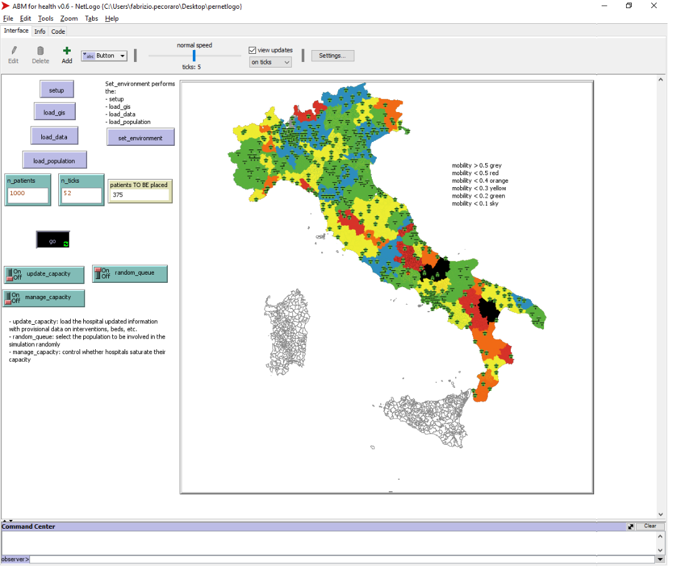

**Figure 1.** Netlogo environment highlighting the preliminary results of one simulation session

The scatterplot diagram reported in Figure 2 highlights the linear regression coefficient and model between the passive mobility gathered from the ABM simulation (x-axis) and the passive mobility computed with the multiple linear regression model (y-axis). As clearly reported by the R-squared (> 0.98), there is a very strong direct relationship between the passive mobility simulated by the proposed model and the passive mobility computed with the multiple linear regression model. A high correlation (R > 0.81) is also present considering the lineare regression between the simulation passive mobility and passive mobility computed with the real hospital values. This result confirm the goodness of the simulation model.

Considering the precision, the ICC computed carrying out five sessions of ABM simulation resulted higher than 0.95 confirming the repeatability of the process.

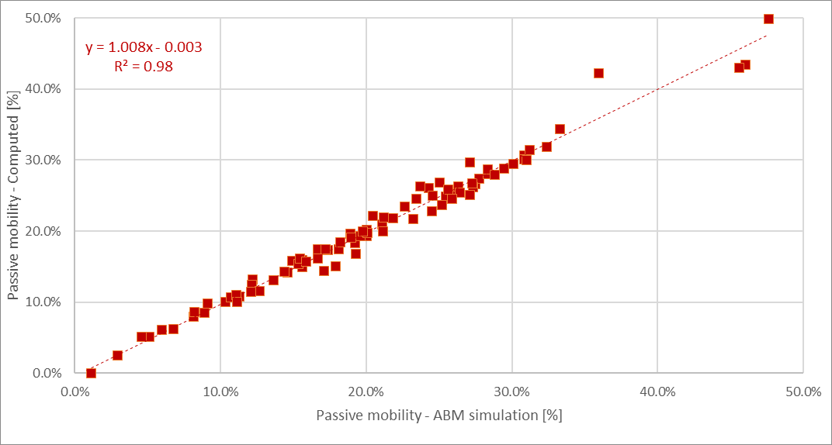

**Figure 2.** Correlation between the passive mobility gathered from the simulation model (x-axis) and the passive mobility computed with the multiple linear regression model (y-axix)

# Discussion and conclusions

XXX Preliminary results to verify the applicability of the ABM for destribing the patient mobility in accessing healthcare services and structures XXX

XXX We applied this model/methodology considering the hip replacement surgery procedure. However, this can be applied also to other elective surgery or curative services, to primary care services, to laboratory analysis services, or even to acute care services, such as intensive care. XXX

XXX Future work: 1) verify the patient’s flows: not only whether the patients remain in their region or not for accessing the service but also which is the destination region/LHU/hospital; 2) modify the basic variables in specific territories and to verify how these changes may impact on patient mobility. This may help policy makers and hospital administrative professionals to capture to what extent these changes may help patients to remain in their region for healthcare service. For instance reducing the waiting times or improving the number of beds available or, even provide an additional point of care in specific part of the region that are not reached by the service under investigation XXX

First paragraph.

Second paragraph.

## Heading

First paragraph.

* Item
* Item
* Item

Second paragraph.



**Figure 1.** Short caption.

**Table 1.** Long caption. Long caption. Long caption. Long caption. Long caption. Long caption. Long caption. Long caption. Long caption

|  |  |  |
| --- | --- | --- |
| **Column1** | **Column2** | **Column3** |
| –10.2 | 10.2 | 10.2 |
| 5.36 | 6.32 | 6.32 |
| –5.7 | 5.7 | 0.326 |

 (1)

References

1. Petitti DB, Crooks VC, Buckwalter JG, Chiu V. Blood pressure levels before dementia. Arch Neurol. 2005 Jan;62(1):112-6, doi: ....
2. Rice AS, Farquhar-Smith WP, Bridges D, Brooks JW. Canabinoids and pain. In: Dostorovsky JO, Carr DB, Koltzenburg M, editors. Proceedings of the 10th World Congress on Pain; 2002 Aug 17-22; San Diego, CA. Seattle (WA): IASP Press; c2003. p. 437-68. doi: ....

SCARTI

The regression model to capture which are the variables that mostly impact on patient mobility. environment/regional system (i.e. waiting time to access to care, patient satisfaction on hospital services) and hospital accessibility in terms of number of beds available for orthopedics services (i.e. structure indicator) interventions performed (i.e. process indicator), rate of patients returned to the hospital for after-surgery issues (i.e. outcome indicator). Usually these indicators consider only the availability of regional resources, neglecting two fundamental aspects of universal care: the accessibility in terms of travel distance and the availability of extra-regional facilities in particular for patients living at the regional borders [9]. For this reason in this study the resources available for each patient are computed considering the accessibility index proposed in [X] and adopted by our research group in previous studies [e.g. X].

1. Corresponding Author: Author Name, Contact details.